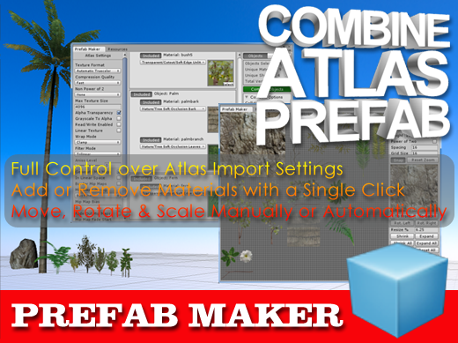

Starting Prefab Maker

After importing the package you will notice a new folder called Prefab Maker has been added to the project window. To open the Prefab Maker window click on the Window menu item in Unity, hover the mouse over the Prefab Maker item and then click on Open Window. The Prefab Maker window is tabbed so you can dock the window by clicking on its tab and dragging it next to the other windows.

About Prefab Maker

Prefab Maker has been designed with ease of use in mind. In short you just select two or more objects that you want to combine and click on the Combine Objects button. You will then be directed to select or create a new folder in your project to group the new assets before the program works to turn them into a prefab. The original objects will be disabled in the hierarchy view and the new prefab will be added. To undo the process you can simply delete the new prefab and enable the original objects by ticking the box next to their name in the inspector.

Getting Started

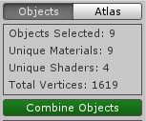
There are two main windows which can be selected by clicking on the buttons at the top right of the window. The first window which is called Objects is the main interface where you can change the atlas settings, include or exclude the objects and materials to be combined or change the settings before combining the objects.
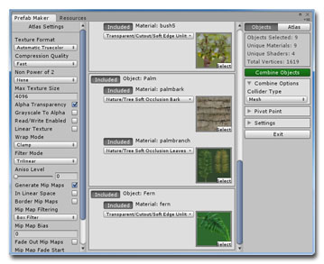

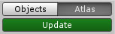
By clicking on the Atlas button you can preview the atlas to move, rotate or scale the textures for a better fit before returning to the main window to combine the objects.
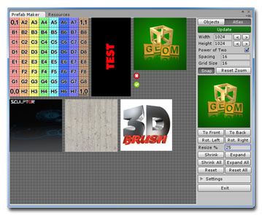

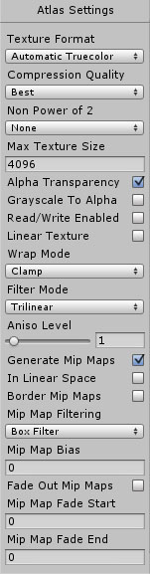
Objects Window

The objects window is divided into three columns. The left column allows you to change the settings for the final atlas. By default it is set to output the highest quality atlas texture but you can change the texture format to make the atlas highly compressed (DXT1 or DXT5) or change any of the other settings to affect the final quality of the atlas. One point to remember is that you can only compress a texture that has dimensions which are a power of two. You can set this by checking the box in the Atlas window.

The middle column shows the objects and materials selected in the scene and you can include or exclude the objects by clicking on the buttons next to their name. You can also change the textures and shaders used by the objects here.

In the third column you can view the number of objects selected, the number of unique materials and the number of unique shaders used by those objects. It also tells you how many vertices will be included in the combined object. The upper limit is set to 65534 vertices and the program cannot combine objects that will result in an object with more than this number of vertices.

Combine Options

The first option is to enable or disable the creation of swatches for materials that use a solid color and no texture. These appear as small 16x16 textures on the final atlas and you can arrange them like any normal texture.

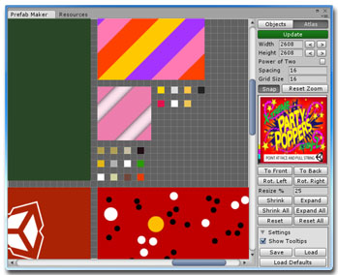

The second option allows you to select the type of collider that will be assigned to the new prefab.

Pivot Point

The Pivot Point foldout contains controls for setting the final pivot point location for the combined objects. This allows you to group objects located anywhere in the scene and still position the pivot point relative to those objects and not just at the world origin. Clicking on the Set To Center button will move the pivot point, which is shown as a small yellow sphere when this foldout is open, to the center of the selected objects. You can also enter the values for the pivot point location in the fields provided or adjust them by clicking on the labels for X, Y and Z and dragging the mouse left and right. To quickly set the pivot point back to the world origin you can click on the Reset button.

Settings

Apart from the option to enable or disable the tooltips, the settings area contains three buttons for saving, loading or resetting the default state for the program. When you click on the Exit button or close the window the current settings for the program are automatically saved and restored when you next open the program.

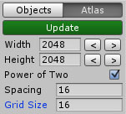
Atlas Window

The atlas window shows how the textures will be arranged in the final atlas texture. In the left hand side of this window you can left click on a texture to select it. The currently active texture is displayed in the center of the right hand column. By left clicking and dragging the mouse on a texture you can drag it to a new position. When the mouse is over the atlas preview area you can also use the scroll wheel to zoom in or out.

At the top of the right hand column you can click on the Update button to automatically rearrange the textures. By default the textures are not reduced in size and the atlas dimensions will expand to fit the textures. This process is not optimal and it is recommended that you manually move, rotate and scale the textures to make for the best atlas while keeping the texture size as small as possible. A future version of Prefab Maker will include more options for automatically arranging the textures, including reducing their size, to make for a better fit.

Below the Update button you can change the dimensions of the atlas by either manually entering new values or by clicking on the buttons to the right of the Width and Height fields. The dimensions of the atlas is shown as a white outline in the atlas preview area.

For most applications you will need to output a texture that has dimensions which are a power of two. Ticking the box marked Power of Two will force the atlas to be compatible with a compressed texture.
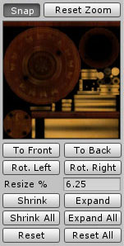
Next you can adjust the spacing between the textures which prevents the colors of textures from bleeding into one another when applied to the combined object.

You can change the visible Grid Size used in the atlas preview area and if the Snap button is selected the textures will auto snap to this grid when being moved.

For convenience you can click on the Reset Zoom button at any time to auto fit the atlas preview into the visible grid view.

Below the texture preview are the controls for manipulating the currently selected texture. You can move it to the front or back of the other textures, rotate the texture left or right as well as shrink or expand the texture by the entered percentage value.

At any time you can reset the currently selected texture back to its original size and rotation or reset all of the textures at once by clicking on the Reset All button.

Resources Window

The Resources window can be accessed by clicking on the tab next to the Prefab Maker tab. This feature gives you an overview of the currently used textures, materials and meshes in the scene. It was so useful to me during the development of this program that I thought it would make a nice accessory to the main program. It was written by Simon Oliver and was kindly placed in the public domain. You can find the original source code for the program here at https://github.com/handcircus/Unity-Resource-Checker

Future Development

As well as developing a better set of automatic texture packing functions it has been requested that an option for removing hidden triangles from the final object be provided.

Other features that will be added in time is support for skinned meshes and the atlasing of tiled textures.

I will continue to work on these features to be added in a future version.

Thank You

A big thanks for your support for Mesh Maker and Prefab Maker. I hope you find it very easy for creating new prefabs and useful in all of your future projects.

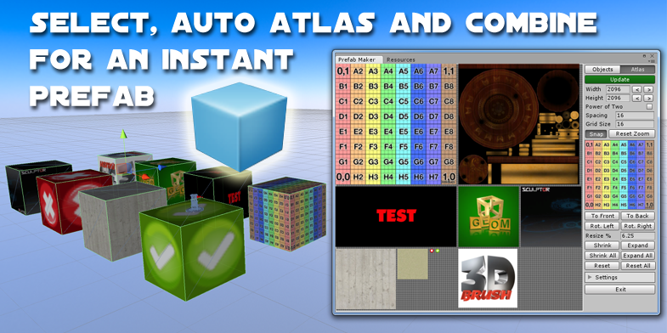

To learn more about Prefab Maker and to view the tutorial videos you can visit
MeshMaker.com

